Task 36

-- create database students;

-- use students;

-- CREATE TABLE users (

-- user_id int auto_increment,

-- user_name varchar(45),

-- user_email varchar(40),

-- user_gender varchar(20),

-- primary key(user_id));

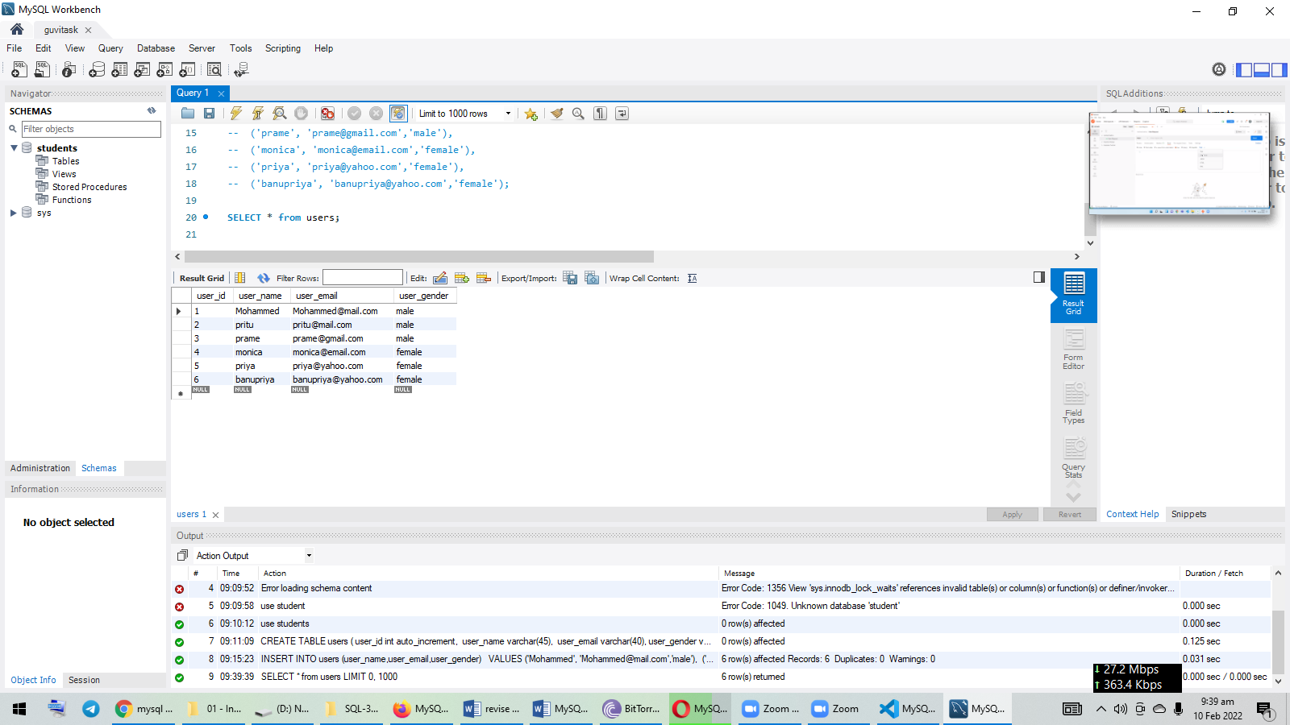

-- INSERT INTO users (user_name,user_email,user_gender)

-- VALUES ('Mohammed', 'Mohammed@mail.com','male'),

-- ('pritu', 'pritu@mail.com','male'),

-- ('prame', 'prame@gmail.com','male'),

-- ('monica', 'monica@email.com','female'),

-- ('priya', 'priya@yahoo.com','female'),

-- ('banupriya', 'banupriya@yahoo.com','female');

-- SELECT * from users;

-- alter table users rename to students;

-- SELECT * from students;

-- alter table students modify user_gender varchar(10);

-- SELECT * from students;

-- alter table students modify user_email varchar(100);

-- SELECT * from students;

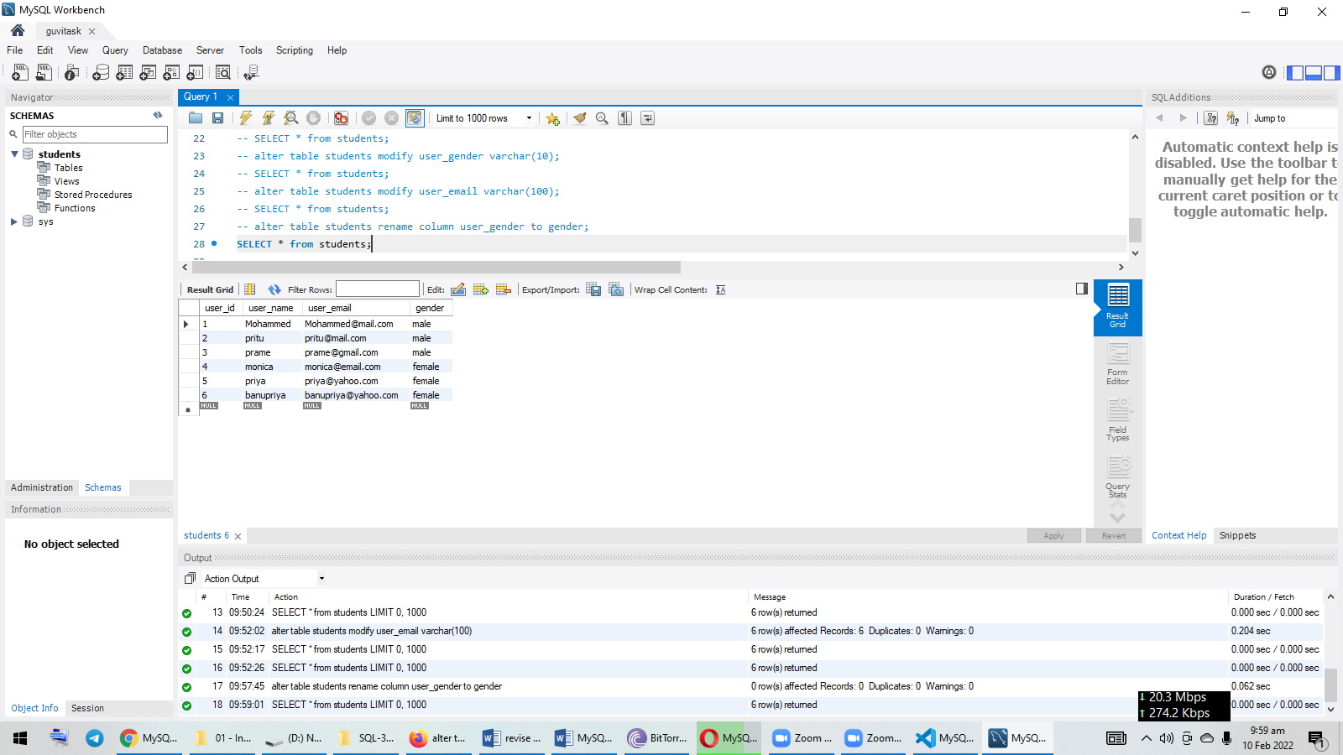

-- alter table students modify user_email varchar(100);

-- SELECT * from students;

-- alter table students rename column user_gender to gender;

-- SELECT * from students;

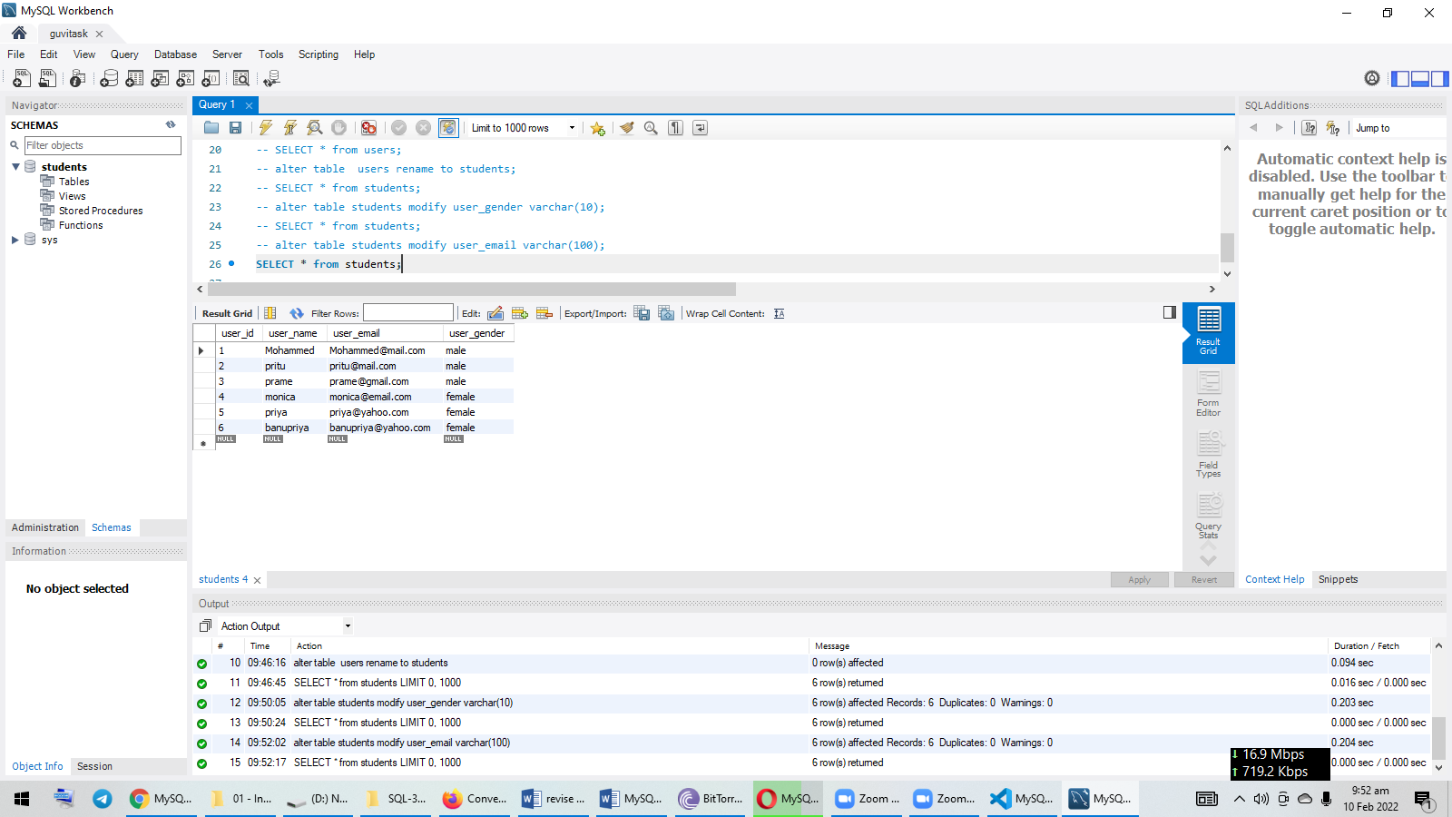

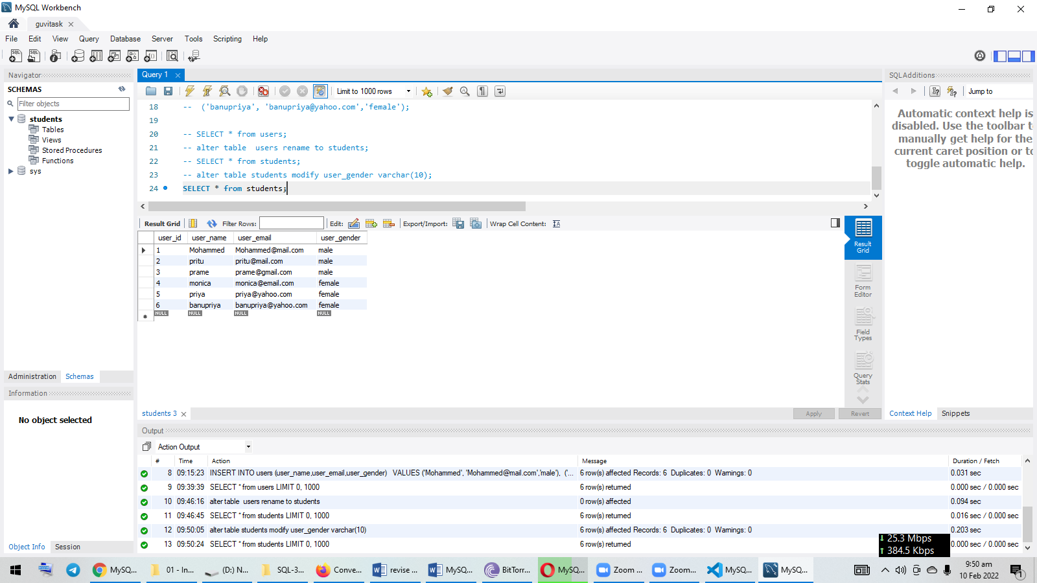

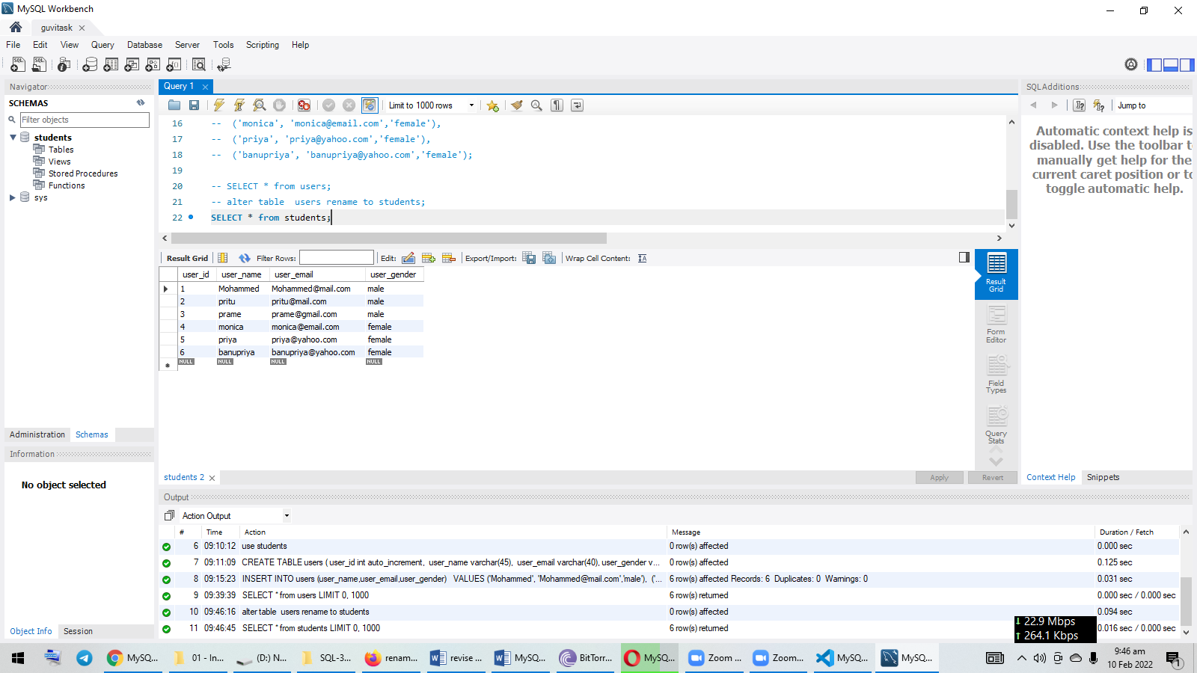

-- alter table students modify user_email varchar(100);

-- SELECT * from students;

-- alter table students rename column user_gender to gender;

-- SELECT * from students;

-- alter table students drop column gender;

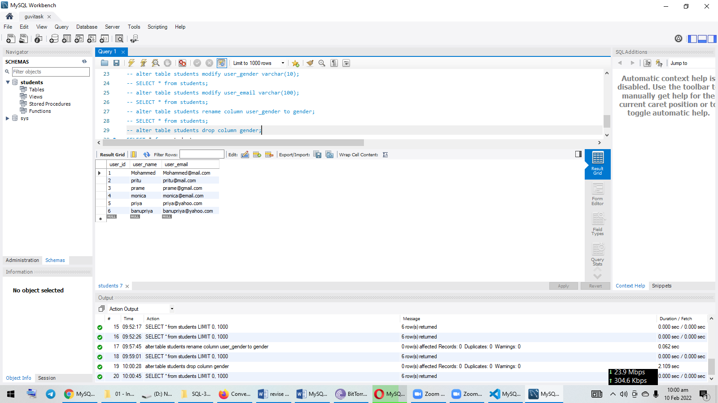

-- SELECT * from students;

-- INSERT INTO students (user_name,user_email)

-- VALUES ('abhinav', 'abhinav-chubb@mail.com')

-- SELECT * from students;

update students set user_email="abhinav-chubb@mail.com" where user_name="abhinav"